x <- sqrt(2)

The value of x is 1.4142 and displayed here.

| Sepal.Length | Sepal.Width | Petal.Length | Petal.Width | noise |
| --- | --- | --- | --- | --- |
| 5.1 | 3.5 | 1.4 | 0.2 | -0.9645671 |
| 4.9 | 3.0 | 1.4 | 0.2 | 0.1690638 |
| 4.7 | 3.2 | 1.3 | 0.2 | 0.8142050 |
| 4.6 | 3.1 | 1.5 | 0.2 | 1.2425016 |
| 5.0 | 3.6 | 1.4 | 0.2 | 1.0587466 |
| 5.4 | 3.9 | 1.7 | 0.4 | 1.0183881 |
| 4.6 | 3.4 | 1.4 | 0.3 | -1.8808384 |
| 5.0 | 3.4 | 1.5 | 0.2 | 0.0337465 |
| 4.4 | 2.9 | 1.4 | 0.2 | 0.3417745 |
| 4.9 | 3.1 | 1.5 | 0.1 | -0.3061266 |

With a caption:

Tab. 1: First 10 observations in the famous iris data set.

| Sepal.Length | Sepal.Width | Petal.Length | Petal.Width | noise |
| --- | --- | --- | --- | --- |
| 5.1 | 3.5 | 1.4 | 0.2 | -0.9646 |
| 4.9 | 3.0 | 1.4 | 0.2 | 0.1691 |
| 4.7 | 3.2 | 1.3 | 0.2 | 0.8142 |
| 4.6 | 3.1 | 1.5 | 0.2 | 1.2425 |
| 5.0 | 3.6 | 1.4 | 0.2 | 1.0587 |
| 5.4 | 3.9 | 1.7 | 0.4 | 1.0184 |
| 4.6 | 3.4 | 1.4 | 0.3 | -1.8808 |
| 5.0 | 3.4 | 1.5 | 0.2 | 0.0337 |
| 4.4 | 2.9 | 1.4 | 0.2 | 0.3418 |
| 4.9 | 3.1 | 1.5 | 0.1 | -0.3061 |

Flextable:

| **Horsepower** | **Weight** | **No. of Gears** | **Miles/Gallon** |
| --- | --- | --- | --- |
| 110 | 2.620 | 4 | *21.0* |
| 110 | 2.875 | 4 | *21.0* |
| 93 | 2.320 | 4 | *22.8* |
| 110 | 3.215 | 3 | *21.4* |
| 175 | 3.440 | 3 | *18.7* |
| 105 | 3.460 | 3 | *18.1* |

Tableone:

## Stratified by Species  
## setosa versicolor virginica   
## n 50 50 50   
## Sepal.Length (mean (SD)) 5.01 (0.35) 5.94 (0.52) 6.59 (0.64)   
## Sepal.Width (mean (SD)) 3.43 (0.38) 2.77 (0.31) 2.97 (0.32)   
## Petal.Length (mean (SD)) 1.46 (0.17) 4.26 (0.47) 5.55 (0.55)   
## Petal.Width (mean (SD)) 0.25 (0.11) 1.33 (0.20) 2.03 (0.27)   
## Species (%)   
## setosa 50 (100.0) 0 ( 0.0) 0 ( 0.0)   
## versicolor 0 ( 0.0) 50 (100.0) 0 ( 0.0)   
## virginica 0 ( 0.0) 0 ( 0.0) 50 (100.0)   
## noise (mean (SD)) 0.07 (0.95) 0.02 (0.99) 0.05 (0.91)

Tableone again:

##   
## Call:  
## lm(formula = mpg ~ 1 + wt, data = mtcars)  
##   
## Residuals:  
## Min 1Q Median 3Q Max   
## -4.5432 -2.3647 -0.1252 1.4096 6.8727   
##   
## Coefficients:  
## Estimate Std. Error t value Pr(>|t|)   
## (Intercept) 37.2851 1.8776 19.858 < 2e-16 ***  
## wt -5.3445 0.5591 -9.559 1.29e-10 ***  
## ---  
## Signif. codes: 0 '***' 0.001 '**' 0.01 '*' 0.05 '.' 0.1 ' ' 1  
##   
## Residual standard error: 3.046 on 30 degrees of freedom  
## Multiple R-squared: 0.7528, Adjusted R-squared: 0.7446   
## F-statistic: 91.38 on 1 and 30 DF, p-value: 1.294e-10

## # A tibble: 2 × 5  
## term estimate std.error statistic p.value  
## <chr> <dbl> <dbl> <dbl> <dbl>  
## 1 (Intercept) 37.3 1.88 19.9 8.24e-19  
## 2 wt -5.34 0.559 -9.56 1.29e-10

## # A tibble: 1 × 12  
## r.squared adj.r.squared sigma statistic p.value df logLik AIC BIC  
## <dbl> <dbl> <dbl> <dbl> <dbl> <dbl> <dbl> <dbl> <dbl>  
## 1 0.753 0.745 3.05 91.4 1.29e-10 1 -80.0 166. 170.  
## # … with 3 more variables: deviance <dbl>, df.residual <int>, nobs <int>

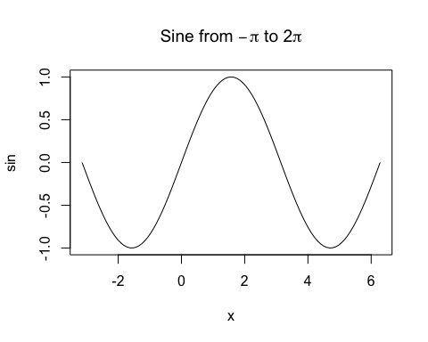

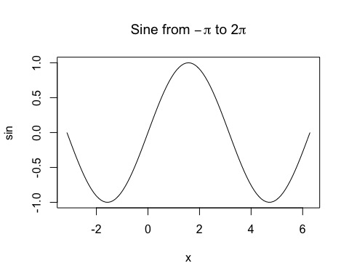

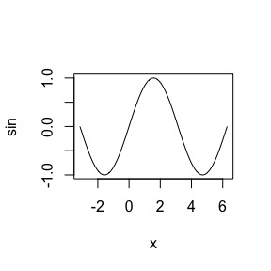

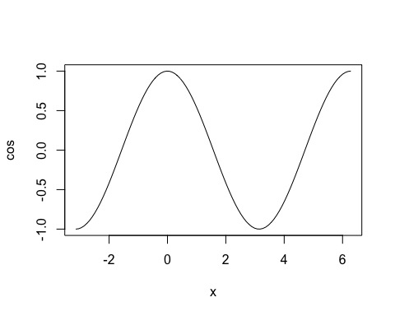

Fig. 2: A Cosine Curve.